**FOR IMMEDIATE RELEASE**

Contact: Kelly Winkler Julie McCrary

White Good White Good

717-690-9768 717-278-0515

kwinkler@whitegood.com [jmccrary@whitegood.com](mailto:jmccrary@whitegood.com)

**Karl Champley Named Host of National Kitchen & Bath Association Podcast**

*Champley joins Jennifer Bertrand to host KBTalks, the only podcast for the kitchen and bath industry*

**HACKETTSTOWN, NJ — (July 15, 2019)** — [KBTalks](https://soundcloud.com/user-171892082), the podcast produced by the National Kitchen & Bath Association (NKBA), the authority on all things residential kitchen and bath, welcomes [Karl Champley, AKBD](https://nkba.org/karl-champley-1), as a new host. Champley, an award-winning master builder, designer and frequent TV and radio personality, joins current host and fellow NKBA member Jennifer Bertrand, AKBD. The two will share hosting duties for the successful podcast, which features in-depth conversations on various K&B-related topics, ranging from business strategies to trends, tech innovations and more. Each episode features respected industry guests sharing their expertise and perspectives about working in the kitchen and bath arena.

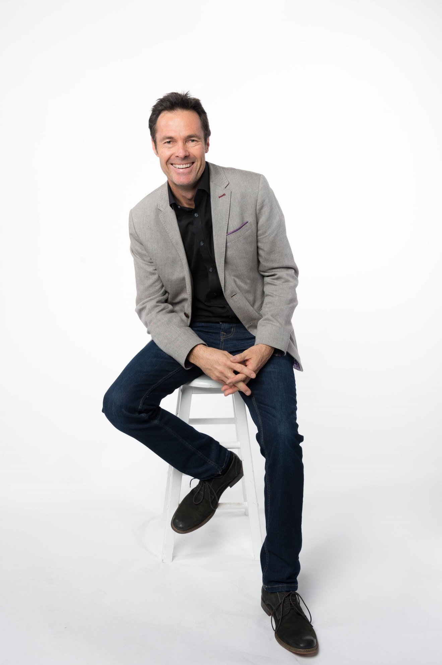“We’re thrilled to have Karl on board as one of the hosts of KBTalks,” said Suzie Williford, chief strategy officer and executive vice president of industry relations for the NKBA. “Karl is a longtime NKBA member and a true industry leader. With his wealth of industry knowledge, he will bring a unique perspective to the conversation.”

Champley, an Australian native, has worked in the industry for more than 35 years designing everything from homes to colleges, libraries, restaurants, and even fire stations. His passionate, no-nonsense approach to home improvement has earned him well-deserved respect in the building industry. He is also a published author and active humanitarian working with various non-profit organizations, including Habitat for Humanity, Adapt A Vet and the NKBA’s NextUp skilled labor initiative.

Learn more about Karl on his [first KBTalks episode](https://soundcloud.com/user-171892082/ep-13-meet-the-new-host-qa-with-karl-champley). KBTalks is available on [Apple Podcasts](https://podcasts.apple.com/us/podcast/kbtalks/id1444655214), [Soundcloud,](https://soundcloud.com/user-171892082) and wherever podcasts are available.

**About the National Kitchen & Bath Association and the Kitchen & Bath Industry Show**

The National Kitchen & Bath Association (NKBA) is the not-for-profit trade association that owns the Kitchen & Bath Industry Show® (KBIS), as part of Design & Construction Week® (DCW). With nearly 14,000 member companies representing tens of thousands of members in all segments of the kitchen and bath industry, the NKBA has educated and led the industry since the association’s founding in 1963. The NKBA envisions a world where everyone enjoys safe, beautiful and functional kitchen and bath spaces. The mission of the NKBA is to inspire, lead and empower the kitchen and bath industry through the creations of certifications, marketplaces and networks. For more information, visit NKBA.org or call 1-800-THE-NKBA (843-6522).

KBIS® and NKBA® are registered trademarks of the National Kitchen & Bath Association.

###